**Disasters as Fuel or Triggers: Modeling the Effects on Social Unrest**

Jimmy Erickson

**Abstract**

**1. Introduction**

Understanding the role of a disaster and modeling its effects on social unrest is complicated. After a disaster occurs, a government’s ability to efficiently go in and provide aid to the affected area is essential to the survival and recovery of the population affected by the disaster. When a government’s actions towards disaster recovery or prevention are not perceived as efficient or effective, a disaster could directly trigger social unrest (Olson, 1998). That is, social unrest activities such as protests could follow immediately after the occurrence of a disaster; this was observed in Beirut, August 2020. An explosion of poorly-stored material resulted in massive destruction, as well as wide-spread demonstrations that led to a number of officials stepping down (BBC, 2020). On the other hand, while a disaster itself might not trigger social unrest in the short term, there are situations where a disaster or a series of disasters could alter various socio-economic factors in the affected population as fuels for grievances and dissatisfaction against certain policy or government (Becker, 2016). With a growing number of disasters in the world today, understanding different aspects of them is growing increasingly important. The effects of disasters are farther-reaching than simply what buildings they destroy. Understanding the features that go into the social effect of a disaster can help in future research into understanding the social effects of disasters. During our research into the topic of disasters and social unrest, there were no papers specifically focused on the social effect of a disaster as either a fuel or trigger for social unrest.Our solution to satisfy this need is to study any possible relations between disasters and social unrest and focus on defining any specific disaster as *fuel* (underlying stress, no immediate unrest) or as a *trigger* (activates underlying stress to cause social unrest). We will be studying these relationships for the purpose of better understanding the nature of disasters in a social context, specifically having to do with unrest. We will be utilizing data about disaster events, data about social unrest events, and other additional datasets that are found to be helpful. This paper will not be focusing on innovation in the field of Computer Science. Instead, we will be focusing on studying the relationship between disasters and social unrest while finding new ways to apply data science techniques to our proposed problem. We will be demonstrating fairly simple data science techniques in order to analyze and model the data, and writing scripts in order to assist in managing the data, but our initial plan does not include computer science innovation.This paper’s main goal is to contribute to the field of disaster research by approaching disasters from the context of unrest. And to use Data Science techniques to build out methods of modeling these events so as to support our research and give a starting point for future research of this topic. We will be generating datasets that are a combination of multiple datasets including GDELT, DesInventar, and other datasets such as infrastructure, demographic wealth inequality, and other datasets that are determined to be relevant to this research.

Overview of the rest of the paper/thesis

***I assume we have to wait until more of the paper is written in order to do the preview part***

Questions:

1. Do we write this with the knowledge we have at the beginning of the project or at the end of the project (i.e. mentioning the datasets we use)

**2. Related Work and Background**

**3. Methodology**

**3.1. Data Sources**

The data sources we are using are the DesInventar and GDELT databases. These databases were chosen because they filled various criteria that made them optimal for our research.

The DesInventar database is a project sponsored by the United Nations to track disaster events around the world and assemble a highly accurate dataset of these disasters. DesInventar partners with universities in each region they are tracking in order to ensure accurate data with minimal undercounting or overcounting. The DesInventar dataset we have for India includes the three states of Uttarakhand, Tamil Nadu, and Orissa for the year range 1985 - 2012. The attributes provided for events in these regions include the following: state, district, block, date, type, sub-type, cause, source, deaths, injuries, and many additional metrics we will not be using for the purpose of this project.

The GDELT database is a project to map all significant events in the world, including social unrest events for 1985-2012, which are the events we will be using from this source and appending to our events from DesInventar. Our GDELT dataset has the following fields: date, source (original actor), target (target actor), CAMEOcode (defines the exact type of event), NumEvents (if there are multiple smaller events that act as one), latitude and longitude.

We did not use ACCLED or ICEWS. The reasoning for this is that the DesInventar database has data consistently until 2012, when their partnerships in India expired. This caused a problem because the ACCLED protest dataset had dates starting in 2012.

**3.2. Data Preparation**

The first step in preparing the data was to combine the three separate datasets we had for DesInventar, which were the three states of India that were supported by this project. Those states are Orissa (Odisha), Tamil Nadu, and Uttarakhand. The DesInventar events are fairly evenly spread out within the states, though not evenly spread out between the states with Orissa having 9,081 events, Tamil Nadu having 15,535 events, and Uttarakhand having 3,879 events. To continue preparing the DesInventar data, we set about getting a latitude and longitude value for each of the DesInventar entries. Since we were given the state and district in which a disaster occurred, we fed that information into the Bing maps API which then returned latitude and longitude values for each of our disasters. For combining them, we went about the process of removing excess columns that we did not want to test out initially in our various modeling methods that are discussed in Section **3.3**. We then formatted each of the columns to have the correct data type so as to be consistent with the events from GDELT (i.e. specifying double/integer, string/date).

To prepare the GDELT data, the *first step was to filter the events based on location*. We used the state shapefiles for India and QGIS to filter the events down to the relevant states (Orissa, Tamil Nadu, and Uttarakhand) that are included in our DesInventar data. The *second step was to filter the GDELT events by event type*. Filtering by event type was done by studying the GDELT documentation on CAMEO codes to determine the events to keep. It was decided to keep events that included *humanitarian aid* or *social unrest events* (see Table 1). The decision to keep humanitarian aid events was made because research into disaster events and social unrest showed that government response to a disaster has a significant impact on potential unrest.

|  |  |
| --- | --- |
| CAMEO Code | Description |
| 073 | **Provide Humanitarian Aid-**  Extend, provide humanitarian aid, mainly in the form of emergency assistance. |
| 140 | **Engage in political dissent, not specified in other codes-**  All civilian demonstrations and other collective actions carried out as protests against the target actor not otherwise specified. |
| 141 | **Demonstrate or rally, not specified below-**  Dissent collectively, publicly show negative feelings or opinions; rally, gather to protest a policy, action, or actor(s). |
| 1411 | **Demonstrate or rally for leadership change-**  Dissent collectively, gather, or rally demanding leadership change. |
| 1412 | **Demonstrate or rally for policy change-**  Dissent collectively, gather, or rally demanding policy change. |
| 1413 | **Demonstrate for rights-**  Dissent collectively, gather, or rally demanding political, social, economic,  or other rights. |
| 1414 | **Demonstrate for change in institutions, regime-**  Dissent collectively, gather, or rally demanding major institutional, constitutional, or regime change. |
| 142 | **Conduct hunger strike, not specified below-**  Protest by refusing to eat until certain demands are met, not further specified. |
| 1421 | **Conduct hunger strike for leadership change-**  Refuse to eat until demands for leadership change are met. |
| 1422 | **Conduct hunger strike for policy change**-  Refuse to eat until demands for policy reform are met. |
| 1423 | **Conduct hunger strike for rights-**  Refuse to eat until demands for political, social, economic, or other rights are met. |
| 1424 | **Conduct hunger strike for change in institutions, regime-**  Description Refuse to eat until demands for major institutional, constitutional, or regime change. |
| 143 | **Conduct strike or boycott, not specified below-**  Protest by refusing to work or cooperate until certain demands are met, not specified further. |
| 1431 | **Conduct strike or boycott for leadership change-**  Refuse to work or cooperate until demands for leadership change are met. |
| 1432 | **Conduct strike or boycott for policy change-**  Refuse to work or cooperate until demands for policy reform are met. |
| 1433 | **Conduct strike or boycott for rights-**  Description Refuse to work or cooperate until demands for political, social, economic, or other rights are met. |
| 1434 | **Conduct strike or boycott for change in institutions, regime-**  Description Refuse to work or cooperate until demands for major institutional, constitutional, or regime change. |
| 144 | **Obstruct passage, block, not specified below-**  Description Protest by blocking entry and/or exit into building or area, not otherwise specified. |
| 1441 | **Obstruct passage to demand leadership change-**  Obstruct passage, block entry/exit to demand leadership change. |
| 1442 | **Obstruct passage to demand policy change-**  Obstruct passage, block entry/exit to demand policy reform. |
| 1443 | **Obstruct passage to demand rights-**  Obstruct passage, block entry/exit to demand political, social, economic, or other rights. |
| 1444 | **Obstruct passage to demand change in institutions, regime-**  Description Obstruct passage, block entry/exit to demand major institutional, constitutional, or regime change. |
| 145 | **Protest violently, riot, not specified below-**  Protest forcefully, in a potentially destructive manner, not further specified. |
| 1451 | **Engage in violent protest for leadership change-**  Protest forcefully, in a potentially destructive manner, to demand leadership change. |
| 1452 | **Engage in violent protest to demand policy change-**  Protest forcefully, in a potentially destructive manner, to demand policy reform. |
| 1453 | **Engage in violent protest to demand rights-**  Protest forcefully, in a potentially destructive manner, to demand political, social, economic, or other rights. |
| 1454 | **Engage in violent protest to demand change in institutions, regime-**  Protest forcefully, in a potentially destructive manner, to demand major institutional, constitutional, or regime change. |

Table 1. ???? Caption

Once the data from our two sources was prepared, the data was combined into a single dataset by appending DesInventar events onto the set of GDELT events. A new column called *timeline_event* was created with three different values to show whether an event was a disaster event, humanitarian aid event, or an unrest event.

**3.2.1. Testing Variables For Significance**

The next step is putting the data in a format that can be used to study the effects of a disaster event. We decided to first test out making **timelines** of GDELT events following each disaster event. In the first version, these timelines start out with a single disaster event, then contain all GDELT (protest/humanitarian aid) events in the following year within 80 kilometers. This method yielded 5,349 individual timelines, with the following statistics: an average of 22.59 events per timeline, median number of 6.0 events per timeline, a maximum of 302 events in a timeline, a minimum of 1 event in a timeline, and a standard deviation of 41.86 between timelines. By looking at the difference between the mean and the median, we can see that our timelines are skewed to the right, meaning we have a few very large timelines, which are most likely from events occurring in urban centers where there would be more GDELT events. The next step is to create variations of these timelines with different parameters (geo-temporal distance).

The different variables that were used to create a set of timelines were: events within 40, 80, or 120 kilometers of the timeline’s origin event, and events that occurred within 180 or 365 days following the origin event. In order to analyze the timelines, one approach that was used was to create graphs of the mean and median values for these parameters for each timeline. This gives us an idea of when/where events generally occur relative to the origin event for that timeline. The results for our multiple timelines can be seen in Table 2, and the corresponding charts can be seen in Figure 1.

|  |  |  |  |  |  |  |
| --- | --- | --- | --- | --- | --- | --- |
| **Km range** | **Day Range** | **Mean** | **Median** | **Max** | **Min** | **Standard Deviation** |
| 40 | 180 | 4.120 | 1 | 220 | 1 | 11.795 |
| 40 | 365 | 7.691 | 2 | 234 | 1 | 24.489 |
| 80 | 180 | 11.175 | 4 | 301 | 1 | 20.310 |
| 80 | 365 | 22.593 | 6 | 302 | 1 | 41.861 |
| 120 | 180 | 17.015 | 8 | 334 | 1 | 24.357 |
| 120 | 365 | 35.510 | 14 | 360 | 1 | 51.821 |

**Table 2.** Timeline Statistics

Heatmap tables (Figure 3) were created to show how many timelines (Z) have Y events, X days from the ‘origin’ (Disaster) event at the beginning of the timeline. We produced two sets of heatmaps; one with only negative (protest) events that occurred after the disaster, and the other had only positive (aid) events that occurred after the disaster.



This format showed that, when it came to negative (protest) events, very few timelines had an increase of protest events within 1-10 days of a disaster. The increase was insignificant and similar small spikes can be seen elsewhere in the heatmap. What stood out was a very large spike between the 260-day (???? vs. the average of ????) and 365-day (??? Vs. the average of ???) mark.

We pursued the following angles while investigating this spike in the 260-365 day range:

* Are the disaster events and protest events seasonal? If the disaster events and protest events were seasonal and the seasons were about 9-12 months apart, it would explain the 270 day separation being so common. The set of disaster events seemed to be fairly evenly spread throughout the year (this can be seen in Figure 2). This observation reduced the possibility that the spike was due to protests being seasonal, occurring at a certain time (or certain times) of each year.

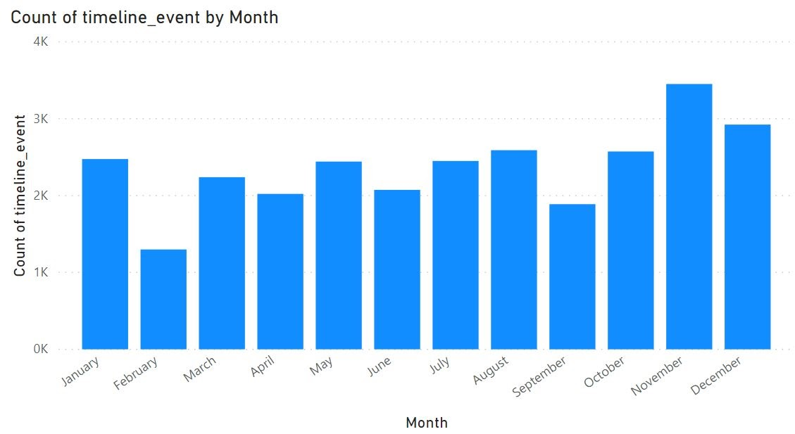

**Figure 2**

* Are disasters with economic impacts of varying size more or less likely to have protest events in the 260-365 day range? If this were the case, then we would see a higher proportion of timelines having events in the bins of interest if we filtered to only timelines with at least a specific impact size. The following points are the results of different ways of looking at the size of a disaster.
* T
* The number of deaths and injuries caused by a disaster.

|  |  |  |  |
| --- | --- | --- | --- |
| Km Range | 40 | 80 | 120 |
| Heat-map |  |  |  |

**Figure 3**

**Figure 3**

**4. Results**

**5. Discussion**

**6. Conclusions and Future Work**

References

Olson, R. S. and A. C. Drury (1998) ‘Disasters and Political Unrest: An Empirical Investigation’, *Journal of Contingencies and Crisis Management*, Volume 6, Number 3, Pages 153-161

Becker, S.L. and Reusser, D.E. (2016) ‘Disasters as opportunities for social change: Using the multi-level perspective to consider the barriers to disaster-related transitions.’, *International Journal of Disaster Risk Reduction*, Volume 18, Pages 75-88

BBC News. “Lebanon's PM-Designate Adib Fails to Form New Government after Blast.” *BBC News*, BBC, 26 Sept. 2020, www.bbc.com/news/world-middle-east-54307896.